**Solidity Hacks: -**

**Access Private Storage Variable: -** we can access the private storage variable of a contract

as all the storage variable are lie inside the blockchain and blockchain is public.

In EVM we have a huge array of 2**256 (slots) where we which stores the variable of size 32 bytes

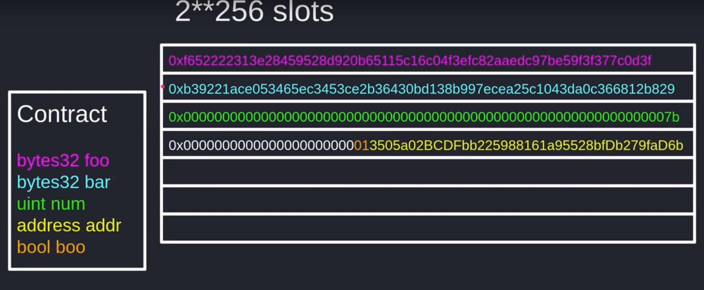

This is how variables are stored inside the EVM, and at last we can see that address and boll are store inside same slot as the combine size of these two variables are less than 32 bytes.

In this attack we have to find the slot of the private variable, then: -

web3.eth.getStorage(address_of_contract, slot_number, console.log)